A WARNING
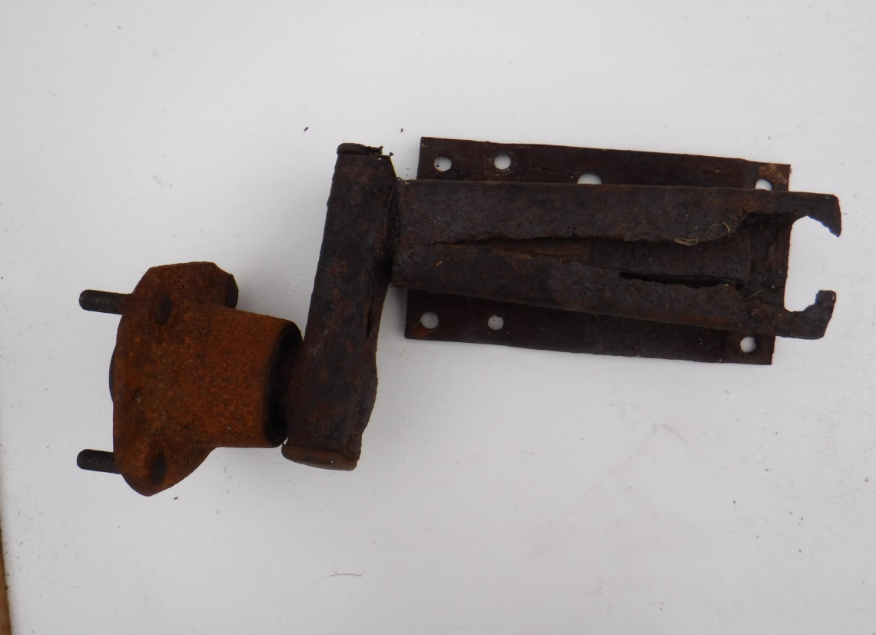
When checking your boat trailer don’t forget to look under the suspension units especially if they are mounted in a channel section; you might miss seeing something like this!
It had been unused for several years but it would have failed disastrously after only one bump!

